NS&I Corporate Social Responsibility Policy
National Savings and Investments (NS&I) is one of the largest savings organisations in the UK with 25 million customers and more than £207 billion invested. NS&I is both a government department and an Executive Agency of the Chancellor of the Exchequer. Our origins can be traced back more than 160 years to 1861. When customers invest in NS&I products, they are lending to the Government. In return the Government pays interest or prizes for Premium Bonds. We offer 100% security on all deposits.
NS&I is a commercially minded government organisation competing in the retail financial services sector in the UK. Whilst we are a relatively small scale employer, we are a large scale organisation. We are committed to running our business in a way that is financially viable and socially and environmentally responsible. To that end, in 2009-10 we developed a Corporate Social Responsibility (CSR) policy that will help us achieve these aims. This policy has been updated in 2020 and 2023 to reflect changes in our business as well as our new five year Corporate Social Responsibility strategy.
Our CSR policy continues to build upon the commitments we have previously made in our Sustainable Development Action Plan (SDAP) and our Carbon Management Plan. It now goes further to embrace the wider corporate social responsibility perspective, beyond the environmental impact of a business. For us, corporate social responsibility is about being a socially responsible corporate citizen in everything we do.
The first CSR Policy focused on engaging and harnessing the enthusiasm of colleagues. The second policy recognised the broader impact we have on customers, communities and our people and how, through our status and activities, we can work towards important social and environmental goals. This policy embraces what has gone before and sets out our five core areas of focus in our CSR Strategy – our five principles - and states how we will measure and report our progress.
It is designed to be a long-term document, so it does not include any specific targets for each year. Instead, those can be found in our annual CSR report, which is published separately and details performance against targets in the reporting year, as well as new targets for the following year.

Our CSR policy
Purpose
NS&I is committed to delivering long-term value to our stakeholders in a way that is both financially viable and socially and environmentally responsible. The purpose of our CSR policy is to help us achieve these aims, providing a clear framework for our activities and consistent governance, such that we will consistently behave as a socially responsible corporate citizen.
The CSR Policy and CSR Strategy fully support the NS&I Inspire & Invest business strategy, in particular, the aims of “Doing the Right Thing” and “Being Inspired and Empowering”.

Ownership
Responsibility for NS&I’s Corporate Social Responsibility (CSR) policy and procedures rests with our Chief Executive as the Accounting Officer for NS&I, and the Executive Committee, in accordance with the NS&I governance framework. The Executive Committee are fully supported by a Workplace and CSR Sub-Committee chaired by the Head of Workplace and Culture who also owns the NS&I Workplace and CSR Risk framework.

Principles
Our CSR policy is built on the following principles:
• NS&I aims to act in a way that is socially and environmentally responsible in all our activities.
• We will continue to comply with all relevant legislative and regulatory requirements around CSR, as well as associated codes of practice.
• We will fully support the Government’s environmental plans (in January 2023 this is shaped by the Net Zero Strategy: Build Back Greener which was published in October 2021) as they apply to our business, and any updates to this.
• We will continue to be transparent, straightforward and fair in all our dealings with our customers.
• Everyone at NS&I has a role to play in ensuring we meet these goals.
These principles have informed the development of the policy and strategy thus far, and will also be an integral part of future reviews. Successful delivery of our CSR policy requires the engagement of our partners in both agreeing and meeting commitments.

Structure
Our CSR policy consists of five core strategic areas of focus:
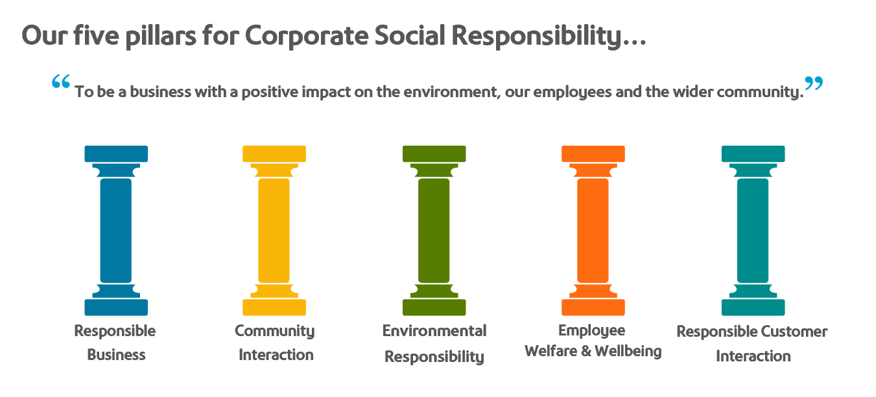
Responsible Business
NS&I will ensure that it runs its business in a responsible manner. We will continue to be recognised for the highest standards of conduct and maintain excellent standards of corporate governance. We commit to maintain excellent standards of regulatory compliance in all fields relevant to our business.
To support the achievement of this strategic aim we have the following policies and practices:
- Business Rules for Conduct, Propriety, and Conflicts of Interest
- Speaking Up
- Living Wage – NS&I is a Living Wage accredited employer and we require all key partners to be likewise.
- Our NS&I website has a section detailing how we operate
- Civil Service Management Code
- Our Information Charter
- Modern Slavery Statement

Community Interaction
NS&I will ensure that it supports the communities around the areas where we work through our continued support of Payroll Giving; providing staff with Volunteering Leave opportunities; and promotion and support of a charity chosen by staff.

Our staff also support other charity causes throughout the year – for example by donating clothes to the Passage homeless shelter and supporting Christmas Jumper Day.

We also support young people by offering apprenticeships and work experience placements.

To support the achievement of this strategic aim we have the following policies and practices:
- Giving Something Back practices
- A nominated charity which we support for a two year period, voted for by our staff.
- Policy and support for staff who provide voluntary support in the areas of School Governors and Justices of the Peace where additional time and resource may be requied.

Environmental Responsibility
NS&I will ensure that it runs its business in an environmentally responsible manner. We will continue to reduce our CO_{2e} emissions, reduce our waste and increase our recycling. We’ll also reduce water and paper consumption across all sites, including our partnership with Atos within this scope.

We commit to maintain excellent standards of regulatory compliance in all fields relevant to our business.
To support the achievement of this strategic aim we have the following policies and practices:
- Travel and Expenses Policy
- Sustainable Mail Accreditation
- Greening Government Commitments we work to achieving

Employee Welfare and Wellbeing
NS&I will ensure that it runs its business in a responsible manner which has full regard for the welfare and wellbeing of its employees. We will continue to maintain excellent standards of diversity and equality.

To support the achievement of this strategic aim we have the following policies and practices:
- Health and Safety Policy with sub policies for Stress Management and Lone Working
- Equality and Diversity
- Recruitment and employee policies can be found on our website careers pages
- Training and Development

Responsible Customer Interaction

Our customers are at the heart of our business. We support savers in securing their financial future with straightforward services, products, information, guidance and choices.

To support the achievement of this strategic aim we have the following policies and practices
Customer Complaints
Accessibility policy
Measuring and reporting progress
We will measure progress on an ongoing basis through monthly risk reporting methodology and also on a quarterly basis through the Workplace and CSR Sub-Committee. In addition, we will publish an annual CSR report, setting out our performance against targets during the year, as well as any key achievements. The report will also highlight any risks to future compliance with our CSR policy and where appropriate, give details of how we propose to mitigate them.
A summary of our CSR performance will also be included in our Annual Report and Accounts, which we are required to present to Parliament.
Reviewing our CSR policy
We will formally review our CSR policy annually, working closely with our business delivery partners. However, we will also update the policy as regulations and government requirements change. Changes will be formally reviewed by the Executive Committee and implemented in a timely way.
Ian Ackerley
NS&I Chief Executive Officer
28 February 2023

