Corporate Social Responsibility 2020-21

Our aims, performance and targets

Contents

Introduction 2
Key achievements – environmental 3
Key achievements – other 4
Energy use and CO_{2e} emissions 6
Water consumption 9
Waste & recycling 10
CSR strategy for 2019-20 12
Appendix: Performance at the sites 14
About NS&I 15

Introduction
This report sets out our performance during 2020-21 against the commitments and targets we set ourselves at the start of the year. It also indicates our Corporate Social Responsibility (CSR) targets for 2021-22 and shows the 2009-10 baseline data, against which we measure our performance. This is our eleventh report detailing progress of the implementation of our CSR policy and measuring our performance.
At NS&I, we see sustainability as an essential part of what makes us an efficient and responsible business and we recognise the need to adapt to climate change. This report provides a breakdown of our performance over the past 12 years against the government sustainability targets (Greening Government Commitments).
The Greening Government Commitments are:
- reduce carbon emissions
- increase energy efficiency in the newer buildings
- increase the proportion of energy from renewable sources
- reduce water consumption
- reduce waste arising
- increase the proportion of waste that can be recycled

In November 2019, we launched our new Corporate Social Responsibility Strategy for 2019-2024, based on the Greening Government Commitments and our NS&I Corporate Strategic theme Doing the Right Thing.

The current CSR policy can be found at https://nsandi-corporate.com/governance/corporate-and-social-responsibility
The tables in this report show relevant figures for 2020-21, as well as the previous three years and the 2009-10 baseline figures, where we have them. The narrative below each table provides additional background information and highlights where we have been able to meet specific government sustainability targets.
The carbon reduction plan, developed with the support of the Carbon Trust, set out how against the 2009-10 baseline, we would reduce our carbon emissions by over 7,000 tonnes a year from the end of March 2015. This equated to over 50% of our emissions, significantly ahead of both our own initial target and those set centrally by government. The plan was developed as part of our participation in the pilot of the carbon management programme for central government supported by the Carbon Trust, which seeks to reduce carbon emissions across government. NS&I was one of 20 central government organisations that chose to participate in the programme. We continue to build on this solid foundation.

NS&I and Atos, our operational delivery partner, have committed to work in partnership to help monitor and measure the environmental aspects of our operations and drive improvements in environmental performance across the whole business in line with Greening Government Commitments.

Key achievements – environmental

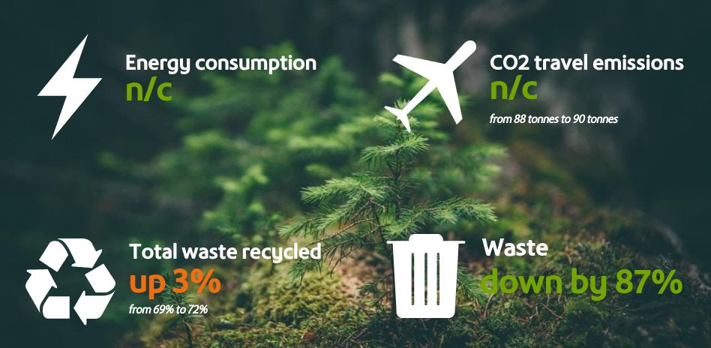

Key achievements – other

This year will be marked for the COVID-19 pandemic and our business, like many, was impacted through the national lockdown restrictions and also the high demand for NS&I’s products and services. So our performance this year in relation to our Corporate Social Responsibility targets has been very different to a normal working year.

In addition to the quantitative measures above, NS&I has continued to introduce more sustainable ways of working across our operations. During 2020-21, under the five pillars of our Corporate Social Responsibility Strategy, we:

- RESPONSIBLE BUSINESS
  - Maintained our commitment and delivery against the Sustainable Mail™ environmental standards for direct mail. The standards cover not only the materials used in mailings – which should be environmentally friendly and recyclable – but also avoiding waste by improving data. By achieving the standards, we are able to carry out mailings at a lower price tariff – creating valuable savings.
  - We have worked across our supply chain to ensure that we comply with the Public Services (Social Value) Act 2012. This means we consider the social, environmental and economic impacts of our strategic procurement activity, securing added value and sustainable outcomes wherever possible.
  - We are a Living Wage employer and are gaining the same commitment throughout our supply chain with at least 29% of our suppliers now verified as committing to the Living Wage.
- ENVIRONMENTAL RESPONSIBILITY
  - Continued our work with our operational delivery partner, Atos, on sustainability measurement and performance through our commitment to the Greening Government Commitments.
  - Achieved full 100% compliance with the ISO14001 standard for our environmental management systems at the London office.
  - Whilst we saw a big reduction in business travel this year, we also had to adjust the way we worked through socially distanced workspaces and as a result we did have to use additional premises and this impacted on our energy consumptions.
  - Our waste figures show a big reduction in waste arising and an improvement in our recycling of waste.

- COMMUNITY INTERACTION
  - Our staff voted for a new charity to support and in April 2020 we started to support the Vauxhall Food Bank. Unfortunately, the COVID-19 lockdown has limited our support, but we have completed various fund raising through online raffles and events, plus we have been able to donate some food supplies. We look forward to working more closely with the Vauxhall Food Bank as we return to more normal ways of working in 2021.
  - Encouraged staff to donate to charity through Payroll Giving – currently 13% of staff are signed up to donate money to good causes on a monthly basis.
- EMPLOYEE WELFARE AND WELLBEING
  - We achieved a SILVER rating in our MIND Wellbeing Index survey results, demonstrating our firm commitment to staff wellbeing.
  - During the COVID-19 lockdown we fully supported our staff in working from home, with wellbeing workshops via telephone and video conferences and social engagement.
  - We introduced a new approach to workplace assessments under the Display Screen Equipment regulations and the self-assessment and training tool has proven invaluable in completing both home and office workstation assessments for all our staff.
  - We have a well-established whistleblowing “speaking up” process and in 2020-21 we continued to raise the profile of how to challenge and raise concerns. Our staff survey results continue to show us up with the best in the Civil Service in this regard.
- CUSTOMER INTERACTION
  - We continue to reduce the amount of paper involved in our customer interactions. Since April 2020, a further 1.3 million new and existing customers are now having Premium Bond prizes that they may win paid directly into their bank accounts or automatically reinvested. More than 86% of our prizes are now paid this way. By March 2021 we had reduced the number of paper warrants that we send to customers to around 400,000 each month, compared with over one million per month in March 2020.
The table below shows our achievements against the Greening Government Commitments over the 11 years of our CSR Plan.
Greening Government Commitment | NS&I performance
Reduce carbon emissions | In 2009-10, our total carbon and greenhouse gases emissions totalled 11,788 tonnes. This has dramatically decreased over the years and now our emissions total under 400 tonnes per annum. | MET
Increase energy efficiency in the newer buildings | Our Blackpool and Durham sites are new builds and have very good BREEAM ratings. Our Glasgow and London sites have also moved from old inefficient buildings to more modern ones. | MET
Increase the proportion of energy from renewable sources | In 2009-10, we had no zero emissions energy. Since 2013 our operational sites all use zero emissions electricity. | MET
Reduce water consumption | We have not been able to accurately report on water consumption due to buildings having shared occupancy. However, it is clear that there has been a reduction on the basis of fewer staff in each site, more efficient systems and controls. | Partially Met
Reduce waste arising | In 2009-10, our waste arising was 1,138 tonnes. The whole business now has less than 200 tonnes per annum. | MET
Increase the proportion of waste that can be recycled | In 2009-10, we recycled 74% of our total waste. Over the past 11 years we have recycled 76% of our total waste. In the same time period we have reduced waste to landfill from over 300 tonnes to a level below 50 tonnes. | MET

Energy use and CO_{2e} emissions
Aim: Reduce carbon emissions from energy consumption by at least 20% from the 2009-10 baseline year by the end of March 2015 and by 30% by March 2020.
Method of calculation | All energy consumption (electricity and gas) for all UK operational sites involved in NS&I business (Blackpool, Durham, Glasgow and London) in kilowatt hours converted to CO_{2e} emissions.
Unit of data collected | All electricity and gas consumed in kilowatt-hours.
Location of conversion tables | https://www.gov.uk/government/publications/greenhouse-gas-reporting-conversion-factors-2018
Restatement of year-on-year performance | Where the conversion factors for previous years have changed, this will be noted in the report within the section where the changes occur.
Assumptions | None
Exclusions | Where the supply is from a renewable source or zero emissions tariff, this is discounted from the calculation.

Performance
Energy consumption |  | 2009-10 Baseline | 2017-18 | 2018-19 | 2019-20 | 2020-21
Non-Financial Indicators (kwh) | Electricity (non-renewable) | 13,395,736 | 502,683 | 606,673 | 385,626 | Est 385,626
 | Electricity (renewable) | 0 | 2,615,495 | 2,117,787 | 1,565,579 | 2,762,964
 | Gas | 14,533,749 | 837,929 | 838,571 | 501,871 | 1,808,243
Financial Indicators (£k) | London | 78 | 80 | 96 | 72 | 138
 | Operational Sites | 1,749 | 249 | 258 | 228 | Not available
 | TOTAL SPEND | 1,827 | 329 | 354 | 300 | Not available
(NB we do not use LPG or any other energy sources)
Note 1 – a change in landlord agents at our head office in 1 Drummond Gate, London, has meant that we have not been able to accurately report electricity or gas consumption as it is a shared service.
The electricity consumption across our operational sites for the 2020-21 financial year saw a 75% increase across the estate against the 2019-20 levels. The fact that we had to alter our operating model during the COVID-19 pandemic with social distancing, meant that we had additional premises and longer operating hours contributing to increased consumption. The London office is no longer reporting on a metered basis; rather an apportioned billing, some of which is through the Service Charge. It is therefore not possible to report actual consumption.

The gas consumption for the financial year saw a substantial increase against the previous year for similar reasons to the electricity data.

Overall energy consumption was considerably higher in 2020-21 than the previous year, but still considerably lower than the baseline year.

CO_{2e} emissions |  | 2009-10 baseline | 2017-18 | 2018-19 | 2019-20 | 2020-21
Non-Financial Indicators (tCO_{2e}) | Total direct emissions (gas) | 2,674 | 154 | 154 | 93 | 425
 | Total indirect emissions (electricity, waste, transport) | 9,114 | 276 | 269 | 173 | 1,459
 | TOTAL | 11,788 | 430 | 423 | 266 | 1,884

Total tonnes CO_{2e} | 2009-10 baseline | 2017-18 | 2018-19 | 2019-20 | 2020-21 | Percentage change against previous year | Percentage change against baseline year
Energy | 11,143 | 331 | 326 | 191 | 617 | 223% increase | 98% reduction
Transport | 573 | 88 | 90 | 70 | 0.3 | 99% reduction | 99% reduction
Waste | 51 | 8 | 7 | 5 | 1,267 | Change in Conversion Factors | Change in conversion factors
TOTAL | 11,788 | 430 | 423 | 266 | 1,884 | 608% increase | 84% reduction

Overall, our CO2e emissions increased this financial year due to higher energy consumption and the big change in conversion factors for waste management. In 2014-15, Atos were successful in transferring all their electricity supplies to be sourced from renewable energy, hence the massive reductions in CO2e emissions. We also had both Lytham and Blackpool operating for customer service needs. In 2021-22 we will see the Blackpool site vacated and sold.

The COVID-19 pandemic had an impact on our business travel CO2e emissions as fewer people had to travel during the year. As a result, we have found new ways of working and will continue to control the level of business travel for the benefit of the environment and for the wellbeing of the staff who have to travel.

It is important to note that, under the Carbon Reduction Energy Efficiency Scheme, Atos is accountable for the operational emissions from the three main offices in Blackpool, Durham and Glasgow. For the London office, the landlord is accountable for the operational emissions and the Carbon Reduction Energy Efficiency Scheme, as the building is shared occupancy and not all sub-metered. Therefore, NS&I has no obligations under the CRC scheme.

Performance against targets
NS&I CO2e emissions |  | 2009-10 baseline | 2017-18 | 2018-19 | 2019-20 | 2020-21 | 2021-22
Non-Financial Indicators (tCO_{2e}) | Total gross emissions | 11,788 | Target 1,800 or less  Actual  430  met | Target  1,800 or less  Actual  423  met | Target  500 or less  Actual  266  met | Target  450 or less  Actual  1,884  Not met | Target  450 or less
 | Gross emissions attributable to official business travel | 573 | Target 143 or less  Actual  88  met | Target  143 or less  Actual  90  met | Target  100 or less  Actual  70  met | Target  70 or less  Actual  0.3  met | Target  70 or less
Financial Indicators (£k) | Expenditure on official business travel | Not applicable | n/a | £335k | To reduce by 30%  Actual  31%  met | To reduce by 10% | Data not available

We no longer have a requirement to report on CRC expenditure.
Energy consumption |  | 2009-10 baseline | 2017-18 | 2018-19 | 2019-20 | 2020-21 | 2021-22
Non-Financial Indicators (kwh) | Electricity (non-renewable) | 13,395,736 | Target 500,000  Actual  502,683 | Target 500,000  Actual  606,673 | Target 600,000  Actual  385,626 (est) | Target  450,000  Data not available | Target  450,000 subject to data availability
 | Electricity (renewable and non-greenhouse polluting) | 0 | Target 5,000,000 and 100%  Actual  2,615,495  100%  met | Target 5,000,000 and 100% for operational sites  Actual  2,117,787  100%  met | Target 3,500,000 and 100% for operational sites  Actual  1,565,579  100%  met | Target below 3,500,000 and 100% for operational sites  Actual  2,762,964  100%  met | Target below 3,500,000 and 100% for operational sites
 | Gas | 14,533,749 | Target 1,000,000  Actual  837,929  met | Target 1,000,000  Actual  838,571  met | Target  900,000  Actual  501,871 (est)  met | Target  Below 750,000  Actual  1,808,243 | Target  Below 700,000

Water consumption
Aim: Reduce water consumption by 25% by 2020 relative to our 2014-15 baseline year
Method of calculation | Total water consumption for London office in m³ of water consumed.
Unit of data collected | Total water consumed in m³ by location.
Location of conversion tables | Not applicable
Restatement of year-on-year performance | Where the conversion factors have changed or other material changes for previous years have occurred, this will be noted in the report within the section where the changes occur.
Assumptions | None
Exclusions | The operational sites at Glasgow, Blackpool and Durham are not solely occupied by NS&I and therefore accurate recording is not possible.

Performance
Water consumption |  | 2009-10 baseline | 2017-18 | 2018-19 | 2019-20 | 2020-21
Non-Financial Indicators (m3) | Water consumption / supplied | 60,635 | 7,925 | 6,647 | Unable to report | Unable to report
Financial Indicators for water supply (£k) | London | Not available | 4 | 3.3 | Unable to report | Unable to report
 | Operational Sites | 264 | 60.1 | 74 | Unable to report | Unable to report
 | TOTAL SPEND | Not available | 64.1 | 77.3 | Unable to report | Unable to report

The water consumption and financial costs data is not available for all sites and therefore cannot be reported. In Glasgow and London, the shared occupancy of the building means that the costs of water are an apportioned rate within the building service charge. This will be the case for the reporting year and going forward.

Performance against targets
Water consumption |  | 2009-10 baseline | 2017-18 | 2018-19 | 2019-20 | 2020-21
Non-Financial Indicators (m³) | Water consumption (supplied water) | 60,635 | Target 24,000  Actual  7,925  met | Target  7,500  Actual  6,647  met | Unable to report | Unable to report

The main use of water within NS&I is to supply water for domestic needs (washroom facilities, kitchens etc).

Waste & recycling
Aim: Reduce waste arising by 25% by 2020 relative to our 2009-10 baseline year
Method of calculation | Total waste for all UK operational sites involved in NS&I business (Blackpool, Durham, Glasgow and London) in tonnes of waste.
Unit of data collected | Tonnes of waste arising by the following categories  - Total waste arising  - Total hazardous waste arising (including electrical) non-landfill  - Total non-hazardous waste to landfill  - Total waste recycled/reused (including organic waste)
Location of conversion tables | Not applicable
Restatement of year-on-year performance | Not applicable
Assumptions | None
Exclusions | None

Aim: Recycle 40% of waste by 2012 and 75% by 2020
Method of calculation | Total waste recycled expressed as a percentage of total waste arising from all categories of waste across all UK NS&I Sites (Blackpool, Durham, Glasgow and London).
Unit of data collected | Tonnes of waste arising by the following categories  - Total waste arising  - Total hazardous waste arising (including electrical) non-landfill  - Total non-hazardous waste to landfill  - Total waste recycled/reused (including organic waste)
Location of conversion tables | Not applicable
Restatement of year-on-year performance | Not applicable
Assumptions | None
Exclusions | None

Performance
Waste |  | 2009-10 Baseline | 2017-18 | 2018-19 | 2019-20 | 2020-21
Non-Financial Indicators (tonnes) | Total hazardous waste | 5 | 1 | 1 | 1 | 0
 | Non-hazardous waste to landfill | 290 | 44 | 42 | 36 | 2.3
 | Non-hazardous waste reused/recycled | 843 | 172 | 145 | 105.8 | 10.7
 | Incinerated waste | N/A | N/A | N/A | N/A | 1.6
 | Total Waste | 1,138 | 217 | 188 | 142 | 15
Financial Indicators (£k) | London | 14 | n/a | n/a | n/a | n/a
 | Operational Sites | 118 | n/a | n/a | n/a | n/a
 | TOTAL SPEND | 132 | n/a | n/a | n/a | n/a

Overall, waste arising from all four sites decreased by 89% against the 2020-21 financial year. Against the baseline year of 2009-10, there is an 98% reduction in total waste arising.

Performance against targets
Waste breakdown and % recycled |  | 2009-10 baseline | 2017-18 | 2018-19 | 2019-20 | 2020-21 | 2021-22
Non-Financial Indicators (tonnes) | Total Waste | 1,138 | Target 700  Actual  217  met | Target 700  Actual  188  met | Target  250 or less | Target  250 or less  Actual  15  met | Target  250 or less
 | Waste Reused / Recycled | 843 | Target  525 with 75% recycled  Actual  171  79% recycled  met | Target  525 with 75% recycled  Actual  145  77% recycled  met | Target of 188 or less with 75% recycled | Target of 188 or less with 75% recycled  Actual  11  72%  met | Target of 188 or less with 75% recycled
 | Waste to landfill or incineration | 290 | Target  200  Actual  44  met | Target  200  Actual  42  met | Target 75 or less | Target 75 or less  Actual  2  met | Target 75 or less
 | Total Hazardous Waste | 5 | Target  3  Actual  1  met | Target  3  Actual  1  met | Target 2 or less | Target 2 or less  Actual  0  met | Target 2 or less

This year’s recycling figure across the business is 72%, which is slightly below the Greening Government Commitment target level of 75% by 2020. A change in approach by the landlord’s contractor at our London office means that not all of our waste is recycled, instead, some is incinerated. This change was outside of our control. Overall, the NS&I business is one with a strong ethos of recycling and a commitment to reducing landfill waste.

CSR strategy for 2019-20
We believe that our CSR Policy has reflected the broader impact we have on customers, communities and our people and how, through our core purpose and activities, we can work towards important social and environmental goals.

We have now developed our new CSR Strategy, summarised in five key themes in the diagram below.

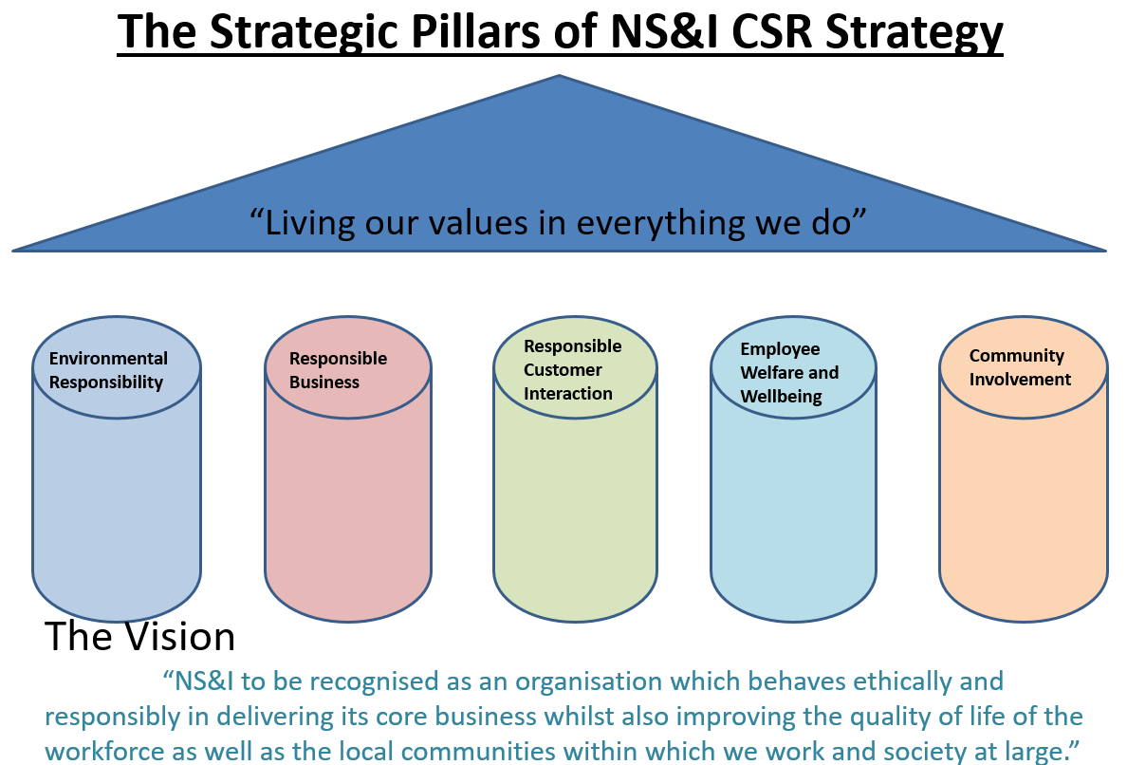

While many aspects of the CSR policy are not measurable in a quantitative way, we will seek to adopt measurable performance targets wherever possible, including specific actions and aims for the year. These will form a key element of the new strategy which will run for five years through to March 2024.

Appendix: Performance at the sites

Comparing our sites
The following table shows the environmental performance of our different sites in 2019-20 and 2020-21 (in bold) compared to the previous three years and the baseline of 2009-10.
Location | Year | Energy  (MwH converted to CO_{2e} tonnes) | Water  (cubic metres) | Waste Arising  (tonnes) | Recycled Waste  (%)
Blackpool | 2009-10 (base) | 2,839 | 30,197 | 191 | 71
 | 2017-18 | 3 | 4,043 | 37 | 71
 | 2018-19 | 2 | 3,269 | 34 | 68
 | 2019-20 | 2.6 | 579 | 33 | 67
 | 2020-21 | 208 | 579 | 3.4 | 75
Durham | 2009-10 (base) | 3,451 | 12,346 | 482 | 66
 | 2017-18 | 96 | 214 | 38 | 74
 | 2018-19 | 92 | 1,636 | 40 | 72
 | 2019-20 | 90 | 1,633 | 31 | 77
 | 2020-21 | 124 | 1259 | 2.4 | 84
Glasgow | 2009-10 (base) | 2,249 | 14,308 | 395 | 85
 | 2017-18 | 0 | N/A | 114 | 78
 | 2018-19 | 0 | N/A | 86 | 78
 | 2019-20 | N/A | N/A | 41 | 59
 | 2020-21 | N/A | NJ/A | 2.7 | 56
London | 2009-10 (base) | 355 | 3,748 | 71 | 73
 | 2017-18 | 287 | 1,741 | 27 | 100
 | 2018-19 | 229 | 1,741 | 28 | 92
 | 2019-20 | 98 | N/A | 9 | 78
 | 2020-21 | N/A | N/A | 6 | 72

About NS&I

NS&I is one of the largest savings organisations in the UK with 25 million customers and more than £202 billion invested.

NS&I is both a government department and an Executive Agency of the Chancellor of the Exchequer. Our origins can be traced back 160 years to 1861.

When customers invest in NS&I products, they are lending to the Government. In return, the Government offers 100% security on all deposits and pays interest or prizes for Premium Bonds.

Our purpose
We want to inspire a stronger savings culture. We believe everyone should have the opportunity to save confidently.

Our mission
- Providing cost-effective financing for government and the public good
- Offering trusted savings and investments propositions
- Delivering valued services for government
- Supporting a fair and competitive market and balancing the interests of our savers, taxpayers and the market.

Our values
Our values are at the heart of everything we do.

We are secure
- With our people
  - We are responsible and do the right thing. We deliver safely and take a balanced approach to innovation and risk.
- With our customers
  - 100% security for savings, backed by HM Treasury. Our digital security is trustworthy. We protect our business.

We are inspiring
- With our people
  - We use fresh thinking for public good. We have a willingness to learn quickly. Diversity, innovation and curiosity are welcomed.
- With our customers
  - Acting decisively and confidently for customers, working with pace to create value and inspiring them to secure their financial future.

We are straightforward
- With our people
  - We have integrity and work together in straightforward ways. What we say matters. We are empowered by our leadership.
- With our customers
  - Clear, ‘everyday’, understandable language. Products designed simply to meet our customers’ needs and easy to use services.

We are reassuringly human
- With our people
  - A small organisation with a big reach. We care for colleagues, respect one another, invest in our people, and manage their talent effectively.
- With our customers
  - We listen to our customers, understand and respond to their needs. We care for customers, our environment and the public good.

Our operating framework
To balance the interests of our savers by offering a fair rate; the taxpayer by delivering long-term cost-effective finance; and the stability of the broader financial services sector by acting transparently and maintaining an appropriate competitive position.

https://nsandi-corporate.com/

