Corporate Social Responsibility 2022-23
Our aims, performance and targets

Contents

Introduction 2
Key achievements – environmental 4
Key achievements – other 4
Energy use and CO_{2e} emissions 6
Water consumption 12
Waste & recycling 14
CSR strategy for 2019-20 16
Appendix: Performance at the sites 19
About NS&I 20

Introduction
This report sets out our performance during 2022-23 against the commitments and targets we set ourselves at the start of the year. It also indicates our Corporate Social Responsibility (CSR) targets for 2023-24 and shows the original 2009-10 baseline data and the new 2017-18 baseline data¹, against which we measure our performance. This is our thirteenth annual report detailing progress of the implementation of our CSR policy and measuring our performance. For the first time this year we are able to compare our results to the new 2017-2018 baseline data. With this new baseline data in place all future reports will use that baseline and we will remove the 2009-10 baseline data from next years report. It is included this year for completeness to show the variation in the baselines.
At NS&I, we see sustainability as an essential part of what makes us an efficient and responsible business and we recognise the need to adapt to climate change. This report provides a breakdown of our performance over the past 14 years against the government sustainability targets (Greening Government Commitments). NS&I operates under an outsourced business model; however, for environmental data reporting we consider the “whole entity” wherever possible and practicable. The only exception is for the outsource partners' business travel and car fleet reporting which they report on in their own annual reports.
The Greening Government Commitments are:
- working towards Net Zero by 2050
- reduce carbon emissions
- increase energy efficiency in the newer buildings
- increase the proportion of energy from renewable sources
- reduce water consumption
- reduce waste arising
- increase the proportion of waste that can be recycled
- reducing environmental impacts from ICT and Digital

In November 2019, we launched our new Corporate Social Responsibility Strategy for 2019-24, based on the Greening Government Commitments and our NS&I Corporate Strategic theme Doing the Right Thing. We are now reviewing this strategy in light of the UK Government’s Net Zero Vision and commitments that have been set out.

The current CSR policy can be found at https://nsandi-corporate.com/governance/corporate-and-social-responsibility
The tables in this report show relevant figures for 2022-23, as well as the previous three years and the baseline figures for both 2009-10 and 2017-18, where we have them. The narrative below each table provides additional background information and highlights where we have been able to meet specific government sustainability targets. Future years will see us report only against the 2017-18 baseline year data.
The carbon reduction plan, developed with the support of the Carbon Trust, set out how (against the 2009-10 baseline) we would reduce our carbon emissions by over 7,000 tonnes a year from the end of March 2015. This equated to over 50% of our emissions, significantly ahead of both our own initial target and those set centrally by government. The plan was developed as part of our participation in the pilot of the carbon management programme for central government supported by the Carbon Trust, which seeks to reduce carbon emissions across government. NS&I was one of 20 central government organisations that chose to participate in the programme. This report shows how we continue to build on this solid foundation.

NS&I and Atos, our operational delivery partner, have committed to work in partnership to help monitor and measure the environmental aspects of our operations and drive improvements in environmental performance across the whole business in line with Greening Government Commitments.

Key achievements – environmental

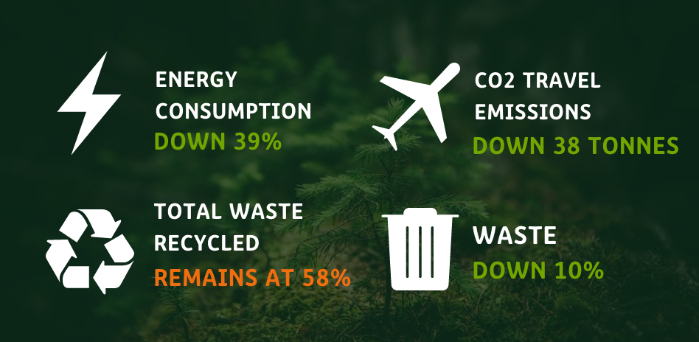

Key achievements - other

This 2022-23 financial year saw us really move out of COVID restrictions and a return to more normal ways of working. However, we also had significant change with our London office relocating to a much smaller temporary location in October 2022. So our performance this year in relation to our Corporate Social Responsibility targets has continued to be different to a normal pre pandemic working year.

In addition to the quantitative measures above, NS&I has continued to introduce more sustainable ways of working across our operations. During 2022-23, under the five pillars of our Corporate Social Responsibility Strategy, we:

- RESPONSIBLE BUSINESS
  - Maintained our commitment and delivery against the Sustainable Mail™ environmental standards for direct mail. The standards cover not only the materials used in mailings – which should be environmentally friendly and recyclable – but also avoiding waste by improving data. By achieving the standards, we are able to carry out mailings at a lower price tariff – creating valuable savings.
  - We have worked across our supply chain to ensure that we comply with the Public Services (Social Value) Act 2012. This means we consider the social, environmental and economic impacts of our strategic procurement activity, securing added value and sustainable outcomes wherever possible.
  - We are a Living Wage employer and are gaining the same commitment throughout our supply chain with at least 37% of our suppliers now verified as committing to the Living Wage.
- ENVIRONMENTAL RESPONSIBILITY
  - Continued our work with our operational delivery partner, Atos, on sustainability measurement and performance through our commitment to the Greening Government Commitments.
  - In our programme of retendering for the outsource operations we have made environmental and social responsibility very strong requirements of all bidders and the requirements are aligned to the Greening Government targets and Net Zero by 2050.
  - Whilst we saw a return to business travel this year, we are mindful of the new ways in which we work following the pandemic and aim to adopt more good practices as a result.
  - Our waste figures show a big reduction in waste arising. However, there has been a deterioration in our recycling of waste against both the 2009-10 and 2017-18 baseline years. This has in part been due to changes in how waste is recycled with some waste now being incinerated rather than recycled. We have continued to reduce the waste sent to landfill.

- COMMUNITY INTERACTION
  - Our staff voted for a new charity to support and in April 2020 we started to support the Vauxhall Food Bank. Unfortunately, the COVID-19 lockdown limited our support, but we have completed various fund raising through online raffles and events, plus we have been able to donate some food supplies.
  - Encouraged staff to donate to charity through Payroll Giving – currently 9% of staff are signed up to donate money to good causes on a monthly basis. There has been a higher level of staff turnover in the past year which has reduced our level of subscription

- EMPLOYEE WELFARE AND WELLBEING
  - We achieved a SILVER rating in our MIND Wellbeing Index survey results for the third year running, demonstrating our firm commitment to staff wellbeing. We further raised the profile of wellbeing in the workplace with a new Wellbeing Hub section on our intranet featuring physical, mental and financial wellbeing support amongst other great support services and advice.
  - In 2022 we reopened our offices and with a move to smaller temporary premises in mind we introduced a working practice of at least 40% of work time in the office and the balance remote.
  - We introduced a new approach to workplace assessments under the Display Screen Equipment regulations and the self-assessment and training tool has proven invaluable in completing both home and office workstation assessments for all our staff.
  - We have a well-established whistleblowing “speaking up” process and in 2022-23 we continued to raise the profile of how to challenge and raise concerns. Our staff survey results continue to show us up with the best in the Civil Service in this regard.
- CUSTOMER INTERACTION
  - We continue to reduce the amount of paper involved in our customer interactions. At March 2023, 90.63% of Premium Bond prizes were paid directly into customers bank accounts or automatically reinvested. Five years ago (March 2018), the figure was 57.82% of prizes.

The table below shows our achievements against the Greening Government Commitments over the 11 years of our CSR Plan.
Greening Government Commitment | NS&I performance
Reduce carbon emissions | In 2009-10, our total carbon and greenhouse gases emissions totalled 11,788 tonnes.  In 2017-18, our total carbon and greenhouse gases emissions totalled 430 tonnes of C0_{2e}  This has dramatically decreased over the years and now our emissions total around 400 tonnes per annum. | MET
Increase energy efficiency in the newer buildings | Our Durham site is a new build and has very good BREEAM ratings. Our Glasgow and London sites have also moved from old inefficient buildings to more modern ones. | MET
Increase the proportion of energy from renewable sources | In 2009-10, we had no zero emissions energy. Since 2013 our operational sites all use zero emissions electricity. | MET
Reduce water consumption | Several of our buildings have other tenants located in them which means some of our water consumption measures are apportioned rather than NS&I specific. | Not Met
Reduce waste arising | In 2009-10, our waste arising was 1,138 tonnes. The 2017-2018 baseline showed how we reduced waste to 430 tonnes and we have held around that level for the years following. This year saw an increase as we moved offices in London and had a big clearout. | MET
Increase the proportion of waste that can be recycled | In 2009-10, we recycled 74% of our total waste. Over the next 11 years we recycled 76% of our total waste. Since then changes in working practices and new ways of dealing with waste have meant a reduction in our performance. | MET with slight detrioration this year.

The new Greening Government Commitments 2021-25 are set out below using the new NS&I baseline of 2017-18 data.
Greening Government Commitment High Level | Detailed measure within the Greening Government Commitment. | NS&I 2017-18 Baseline where available | 2022-23 Progress
Reduce overall greenhouse gas emissions (GHG) from a 2017-18 baseline by 60% | Reduce direct GHG emissions from a 2017-18 baseline by 40%  Reduce domestic business flights by at least 30% from 2017-18 baseline and report distance travelled by international flights. | 154 tonnes  Data not yet available | 144 tonnes actual - 6% reduction  Baseline emissions for transport 88tonnes. 2023 = 32 tonnes (64% reduction)
Reduce the amount of waste by 15% from 2017-18 Baseline | Achieve 15% reduction in overall waste from 2017-18 baseline  Reduce the amount of waste going to landfill to less than 5% of overall waste  Increase the proportion of waste recycled to at least 70% of overall waste  Remove consumer single use plastics  Reduce government paper use by at least 50% from 2017-18 baseline | MET  Landfill waste 42t = 22% of total  79%  No data available  Data not available | Landfill waste 15t = 34% of total  58%  No data available  Data not available
Reducing water use | Reduce water consumption by at least 8% from the 2017-18 baseline  Ensure all water consumption is measured  Provide qualitative assessment to show what is being done to encourage the efficient use of water | 7925m³  Yes, all sites are metered but not necessarily our space, so apporioned levels apply | 17,555m³  Yes, all sites are metered but not necessarily our space, so apporioned levels apply
Sustainable products and services | Continue to buy more sustainable and efficient products and services with the aim of achieving the best long-term value for money  Embed compliance with Government Buying Standards  Understand and reduce supply chain impacts and risks. | No data available  No data available  No data available
Climate Change | Establish clear lines of accountability for climate adaptation in estates and operations | Atos responsibility for all three operational sites.  NS&I responsible for London head office | Atos responsibility for all three operational sites.  NS&I were responsible for London head  office at 1 Drummond Gate but from October 2023 now occupy a Government Hub in Westminster where accountability will rest with the Government Property Agency.
ICT |  | Data not available

Energy use and CO_{2e} emissions
Aims:
Mitigating climate change: working towards Net Zero by 2050
Reduce direct GHG emissions from a 2017-18 baseline by 40%

Method of calculation | All energy consumption (electricity and gas) for all UK operational sites involved in NS&I business (Blackpool/Lytham, Durham, Glasgow and London) in kilowatt hours converted to CO_{2e} emissions.
Unit of data collected | All electricity and gas consumed in kilowatt hours.
Location of conversion tables | Greenhouse gas reporting: conversion factors 2021 - GOV.UK (www.gov.uk)
Restatement of year-on-year performance | Where the conversion factors for previous years have changed, this will be noted in the report within the section where the changes occur.
Assumptions | For the London, Glasgow and Lytham operational sites, much of the reporting is limited due to the fact that there are apportioned allocations based on percentage of space occupied and the financial costs are incorporated into overarching service charge payments.
Exclusions | Where the supply is from a renewable source or zero emissions tariff, this is discounted from the calculation of CO2e but shown in terms of consumption levels.  Due to the apportionment of consumption in various locations, the financial costs are incorporated into overarching service charge payments and therefore cannot be reported.

Performance
Energy consumption |  | 2009-10 Baseline | 2017-18 Baseline | 2019-20 | 2020-21 | 2021-22 | 2022-23
Non-Financial Indicators (kwh) | Electricity (non-renewable) | 13,395,736 | 509,532 | 385,626 | Est 385,626 | 45,442 | 80,358
 | Electricity (renewable) | 0 | 2,174,140 | 1,565,579 | 2,762,964 | 2,518,171 | 1,106,457
 | Gas | 14,533,749 | 696,841 | 501,871 | 1,808,243 | 668,111 | 785,116
Financial Indicators (£k) | London | 78 | 77 | 72 | 138 | Not available | Not available
 | Operational Sites | 1,749 | 193 | 228 | Not available | Not available | £295,100
 | TOTAL SPEND | 1,827 | 270 | 300 | Not available | Not available | Not available
(NOTE
1) we do not use LPG or any other energy sources
2) For both the Lytham and Glasgow operational sites, the electricity data is estimates
3) For the Durham operational site, the gas data is estimated
4) London utility data is an apportioned calculation, so no actual costs are provided as they are included in an overall service charge calculation.

The electricity consumption across our operational sites for the 2022-23 financial year saw a 41% decrease across the estate against the 2021-22 levels. Our London data is distorted as we moved offices in October 2022 and therefore for a three month period had two buildings which were consuming electricity and gas. The London office is our only site where electricity is from non-renewable sources due to the supply being controlled by the landlord of the building.

The gas consumption for the 2022-23 financial year saw an increase against the previous year. This is in part due to the fact the London office moved in October 2022 but there were three months of the year (autumn/winter) when we had gas consumption for both properties. The operational sites also saw an increase in gas consumption largely due to an expansion of operations in both Durham and Glasgow.

Overall energy consumption was 39% lower in 2022-23 than the previous year.

When compared to both the 2009-10 original baseline date and also against the new 2017-=18 baseline date, the overall energy consumption is considerably lower in both instances. For future annual reports we will be using the 2017-18 baseline data which enables us to meet the reporting guideline changes brought about as a result of the UK Government's commitment to Net Zero by 2050.

CO_{2e} emissions |  | 2009-10 baseline | 2017-18 baseline | 2019-20 | 2020-21 | 2021-22 | 2022-23
Non-Financial Indicators (tCO_{2e}) | Total direct emissions (gas) | 2,674 | 154 | 93 | 425 | 116 |  | 144
 | Total indirect emissions (electricity, waste, transport) | 9,114 | 276 | 173 | 1,459 | 89 |  | 48
 | TOTAL | 11,788 | 430 | 266 | 1,884 | 205 |  | 192

Total tonnes CO_{2e} | 2009-10 baseline | 2017-18 baseline | 2019-20 | 2020-21 | 2021-22 | 2022-23 | Percentage change against previous year | Percentage change against baseline year 2017-18
Energy | 11,143 | 331 | 191 | 617 | 126 | 159 | 26%  increase | 52% decreasee
Transport | 573 | 88 | 70 | 0.3 | 70 | 32 | 54%  decrease | 63% decrease
Waste | 51 | 8 | 5 | 1,267 | 9 | 1 | 89% decrease | 88% decrease
TOTAL | 11,788 | 430 | 266 | 1,884 | 205 | 192 | 9% decrease | 55% decrease

Overall, our CO2e emissions decreased by 6% this financial year due to lower emissions from travel and waste. Compared to the 2017-18 baseline year, our total emissions were 55% lower.
This financial year, energy consumption did increase in London due to the office move requiring both offices operating for a short period.

It is important to note that, under the Carbon Reduction Energy Efficiency Scheme, Atos is accountable for the operational emissions from the three main offices in Lytham, Durham and Glasgow. For the London office, the landlord is accountable for the operational emissions and the Carbon Reduction Energy Efficiency Scheme, as the building is shared occupancy and not all sub-metered. Therefore, NS&I has no obligations under the CRC scheme.

Performance against targets
NS&I CO2e emissions |  | 2009-10 baseline | 2017-18 baseline | 2019-20 | 2020-21 | 2021-22 | 2022-23 | 2023-24
Non-Financial Indicators (tCO_{2e}) | Total gross emissions | 11,788 | 430 | Target  500 or less  Actual  266  met | Target  450 or less  Actual  1,884  Not met | Target  450 or less  Actual  205  Met | Target  450 or less  Actual  192  Met | Target  400 or less
 | Gross emissions attributable to official business travel | 573 | 88 | Target  100 or less  Actual  70  met | Target  70 or less  Actual  0.3  met | Target  70 or less  Actual  70  Met | Target  70 or less  Actual  32  Met | Target 70 or less
Financial Indicators (£k) | Expenditure on official business travel | Not applicable | n/a | To reduce by 30%  Actual  31%  met | To reduce by 10% | Data not available | Data not available | Data not available

We no longer have a requirement to report on CRC expenditure.
Energy consumption |  | 2009-10 baseline | 2017-18 baseline | 2019-20 | 2020-21 | 2021-22 | 2022-23 | 2023-24
Non-Financial Indicators (kwh) | Electricity (non-renewable) | 13,395,736 | 502,683 | Target 600,000  Actual  385,626 (est) | Target  450,000  Data not available | Target  450,000  Actual  45,442 | Target  Below 350,000  Actual  80,358  MET | Target  Below 350,000
 | Electricity (renewable and non-greenhouse polluting) | 0 | 2,615,495 | Target 3,500,000 and 100% for operational sites  Actual  1,565,579  100%  met | Target below 3,500,000 and 100% for operational sites  Actual  2,762,964  100%  met | Target below 3,500,000 and 100% for operational sites  Actual  2,518,171  100%  met | Target  Below 2,800,000 and 100% for operational sites  Actual  1,106,457  MET | Target  Below 2,800,000 and 100% for operationalo sites
 | Gas | 14,533,749 | Target 1,000,000  Actual  838,571  met | Target  900,000  Actual  501,871 (est)  met | Target  Below 750,000  Actual  1,808,243 | Target  Below 700,000  Actual  668,111  met | Target  Below 700,000  Actual  785,116  Not met | Target  Below 700,000

Water consumption
Aim: Reduce water consumption by at least 8% from the 2017-18 baseline.
Method of calculation | Total water consumption for London, Durham and Blackpool/Lytham offices in m³ of water consumed.
Unit of data collected | Total water consumed in m³ by location.
Location of conversion tables | Greenhouse gas reporting: conversion factors 2021 - GOV.UK (www.gov.uk)
Restatement of year-on-year performance | Where the conversion factors have changed or other material changes for previous years have occurred, this will be noted in the report within the section where the changes occur.
Assumptions | None
Exclusions | The operational site at Glasgow is not solely occupied by NS&I and therefore accurate recording is not possible as there is no direct apportionment of consumption.

Performance
Water consumption |  | 2009-10 baseline | 2017-18  baseline | 2019-20 | 2020-21 | 2021-22 | 2022-23
Non-Financial Indicators (m3) | Water consumption / supplied | 60,635 | 7,925 | Unable to report | Unable to report | 4,114 | 17,555
Financial Indicators for water supply (£k) | London | Not available | 3.3 | Unable to report | Unable to report | Unable to report | Unable to report
 | Operational Sites | 264 | 74 | Unable to report | Unable to report | Unable to report | Unable to report
 | TOTAL SPEND | Not available | 77.3 | Unable to report | Unable to report | Unable to report | Unable to report

The water consumption and financial costs data is not available for all sites and in some sites, Glasgow and London, the shared occupancy of the building means that the costs of water are an apportioned rate within the building service charge. This will be the case for the reporting year and going forward. It also is noted that the Drummond Gate London water meters had issues during the year which lead to accumulation of data.

Performance against targets
Water consumption |  | 2009-10 baseline | 2017-18  baseline | 2019-20 | 2020-21 | 2021-22 | 2022-23 | 2023-24
Non-Financial Indicators (m³) | Water consumption (supplied water) | 60,635 | 7,925 | Unable to report | Unable to report | Target not set  Actual  4,114 | Target – below 5000  Actual  17,555 | Target – below 8,000

The main use of water within NS&I is to supply water for domestic needs (washroom facilities, kitchens etc).

Waste & recycling
Aim:Reduce the overall amount of waste generated by 15% from the 2017-18 baseline.
Method of calculation | Total waste for all UK operational sites involved in NS&I business (Blackpool/Lytham, Durham, Glasgow and London) in tonnes of waste.
Unit of data collected | Tonnes of waste arising by the following categories  - Total waste arising  - Total hazardous waste arising (including electrical) non-landfill  - Total non-hazardous waste to landfill  - Total waste recycled/reused (including organic waste)
Location of conversion tables | Not applicable
Restatement of year-on-year performance | Not applicable
Assumptions | None
Exclusions | None

Method of calculation | Total waste recycled expressed as a percentage of total waste arising from all categories of waste across all UK NS&I sites (Blackpool/Lytham, Durham, Glasgow and London).
Unit of data collected | Tonnes of waste arising by the following categories  - Total waste arising  - Total hazardous waste arising (including electrical) non-landfill  - Total non-hazardous waste to landfill  - Total waste recycled/reused (including organic waste)
Location of conversion tables | Not applicable
Restatement of year-on-year performance | Not applicable
Assumptions | None
Exclusions | None

Performance
Waste |  | 2009-10 Baseline | 2017-18  baseline | 2019-20 | 2020-21 | 2021-22 | 2022-23
Non-Financial Indicators (tonnes) | Total hazardous waste | 5 | 1 | 1 | 0 | 0 | 0.27
 | Non-hazardous waste to landfill | 290 | 42 | 36 | 2.3 | 17.8 | 15.16
 | Non-hazardous waste reused/recycled | 843 | 145 | 105.8 | 10.7 | 28.6 | 25.5
 | Incinerated waste | N/A | N/A | N/A | 1.6 | 1.9 | 2.9
 | Total Waste | 1,138 | 188 | 142 | 15 | 48.5 | 43.8
Financial Indicators (£k) | London | 14 | n/a | n/a | n/a | n/a | n/a
 | Operational Sites | 118 | n/a | n/a | n/a | n/a | n/a
 | TOTAL SPEND | 132 | n/a | n/a | n/a | n/a | n/a

Overall, waste arising from all four sites decreased by 10% against the 2021-22 levels. Against the baseline year of 2017-18, there is a 77% reduction in total waste arising.

At this point in time we are seeking to establish our consumption of single use plastic. In line with legislative changes in the UK, we aim to remove single use plastics from our business before 2025.
Performance against targets
Waste breakdown and % recycled |  | 2009-10 baseline | 2017-18  baseline | 2019-20 | 2020-21 | 2021-22 | 2022-23 | 2023-24
Non-Financial Indicators (tonnes) | Total Waste | 1,138 | 217 | Target  250 or less | Target  250 or less  Actual  15  met | Target  250 or less  Actual  49  met | Target  200 or less  Actual  44  met | Target  200 or less
 | Waste Reused / Recycled | 843 | 172 | Target of 188 or less with 75% recycled | Target of 188 or less with 75% recycled  Actual  11  72%  met | Target of 188 or less with 75% recycled  Actual  29  59%  Partial met | Target of 180 or less with 75% or more recycled  Actual  25.5t  58%  Partial met | Target of 180 or less with 75% or more recycled
 | Waste to landfill or incineration | 290 | 44 | Target 75 or less | Target 75 or less  Actual  2  met | Target 75 or less  Actual  20  met | Target 10 or less to landfill  Actual  15.16  not met | Target 10 or less to landfil
 | Total Hazardous Waste | 5 | 1 | Target 2 or less | Target 2 or less  Actual  0  met | Target 2 or less  Actual  0.2  met | Target 2 or less  Actual  0.27  met | Target 2 or less

This year’s recycling figure across the business is 58%, which is below the Greening Government Commitment target level of 70%. A change in approach by the landlord’s contractor at our London office means that not all of our waste is recycled instead some is incinerated however, we remain committed to zero to landfill within our measures for the London site. This change was outside of our control. Overall, the NS&I business is one with a strong ethos of recycling and a commitment to reducing landfill waste.

CSR strategy for 2019-24
We believe that our CSR Policy has reflected the broader impact we have on customers, communities and our people and how, through our core purpose and activities, we can work towards important social and environmental goals.

We have now developed our new CSR Strategy, summarised in five key themes in the diagram below.

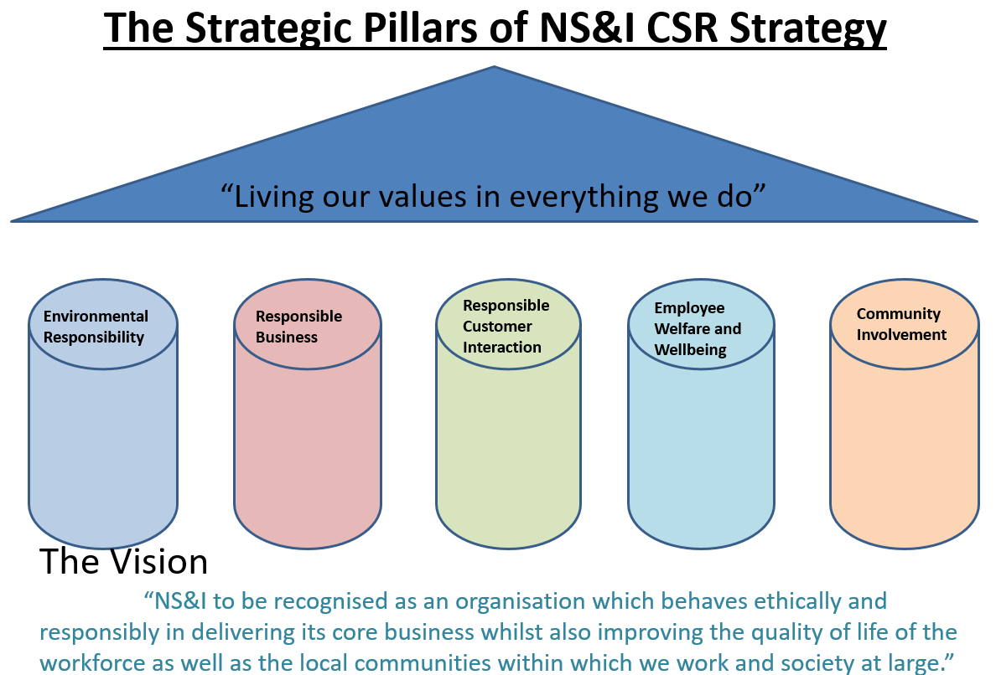

While many aspects of the CSR policy are not measurable in a quantitative way, we will seek to adopt measurable performance targets wherever possible, including specific actions and aims for the year. These will form a key element of the new strategy which will run for five years through to March 2024. The time period of the strategy links with the end date of the current outsourced contract and clearly we will be working on the strategies beyond that date and the new providers of services when they come on board.
Within our “responsible business” strategic theme, NS&I can report the following
- We are a Living Wage Employer and apply this standard to our outsource providers and contractors
- We work within the Government procurement frameworks to ensure we secure value for money and social value from our business partners.

Our future plans for the “responsible environment” strategic theme include
- Validating our 2017-18 baseline in order to report against that for 2022/23 financial year
- Undertaking a Climate Change Risk Assessment and then setting out our action plan for climate change as it could impact our business

Our Employee Wellbeing is very important at NS&I, to that end we currently have put in place
- MIND Wellbeing Index assessments and we are an established SILVER accredited organisation. We are working on developing further strategies based on the feedback received
- We have a team of Mental Health First Aiders to support colleagues as needed and a wealth of support tools covering physical, financial and mental wellbeing.

Our “responsible community” support continues through three core strands
- All our employees are able to give something back to the community be it in a very structured manner such as a school governor or in a less formal route of using up to three days Giving Something Back leave to support a local charity group.
- Our commitment to financial contributions to good causes through Payroll Giving is strong and available to all employees. We promote this at least annually so that our staff can give to good causes.
- Our “staff charity” is voted for by our employees on a two year cycle. We have been supporting the Vauxhall Food Bank for the past two years.

Appendix: Performance at the sites

Comparing our sites
The following table shows the environmental performance of our different sites in 2021-22 and (in bold) compared to the previous three years and the baseline of 2009-10.
Location | Year | Energy  (MwH converted to CO_{2e} tonnes) | Water  (cubic metres) | Waste Arising  (tonnes) | Recycled Waste  (%)

Blackpool up to 2020 and then Lytham | 2009-10 (base) | 2,839 | 30,197 | 191 | 71
 | 2017-18 (base) | 481 | 4,043 | 37 | 71
 | 2018-19 | 2 | 3,269 | 34 | 68
 | 2019-20 | 2.6 | 579 | 33 | 67
 | 2020-21 | 208 | 579 | 3.4 | 75
 | 2021-22 | 3.22 | 2,114 | 4.2 | 76
 | 2022-23 | 90 | 15,836 | n/a | n/a
Durham | 2009-10 (base) | 3,451 | 12,346 | 482 | 66
 | 2017-18 base | 96 | 214 | 38 | 74
 | 2018-19 | 92 | 1,636 | 40 | 72
 | 2019-20 | 90 | 1,633 | 31 | 77
 | 2020-21 | 124 | 1,259 | 2.4 | 84
 | 2021-22 | 113 | 1,306 | 10.7 | 71
 | 2022-23 | 40 | 1,094 | 9.5 | 64
Glasgow | 2009-10 (base) | 2,249 | 14,308 | 395 | 85
 | 2017-18 | 0 | N/A | 114 | 85
 | 2018-19 | 0 | N/A | 86 | 78
 | 2019-20 | N/A | N/A | 41 | 59
 | 2020-21 | N/A | NJ/A | 2.7 | 56
 | 2021-22 | N/A | N/A | 2.99 | 54
 | 2022-23 | 0 | N/A | 27.3 | 56
London | 2009-10 (base) | 355 | 3,748 | 71 | 73
 | 2017-18 base | 287 | 1,741 | 27 | 100
 | 2018-19 | 229 | 1,741 | 28 | 92
 | 2019-20 | 98 | N/A | 9 | 78
 | 2020-21 | N/A | N/A | 6 | 72
 | 2021-22 | 16 | 693 | 4 | 52
 | 2022-23 | 29 | 625 | 7 | 59

About NS&I

NS&I is one of the largest savings organisations in the UK with more than 24 million customers and over £218 billion invested.

NS&I is both a government department and an Executive Agency of the Chancellor of the Exchequer. Our origins can be traced back more than 160 years to 1861.

When customers invest in NS&I products, they are lending to the Government. In return, the Government offers 100% security on all deposits and pays interest or prizes for Premium Bonds.

Our purpose
We want to inspire a stronger savings culture. We believe everyone should have the opportunity to save confidently.

Our mission
- Providing cost-effective financing for government and the public good
- Offering trusted savings and investments propositions
- Delivering valued services for government
- Supporting a fair and competitive market and balancing the interests of our savers, taxpayers and the market.

Our values
Our values are at the heart of everything we do.

We are secure
- With our people
  - We are responsible and do the right thing. We deliver safely and take a balanced approach to innovation and risk.
- With our customers
  - 100% security for savings, backed by HM Treasury. Our digital security is trustworthy. We protect our business.

We are inspiring
- With our people
  - We use fresh thinking for public good. We have a willingness to learn quickly. Diversity, innovation and curiosity are welcomed.
- With our customers
  - Acting decisively and confidently for customers, working with pace to create value and inspiring them to secure their financial future.

We are straightforward
- With our people
  - We have integrity and work together in straightforward ways. What we say matters. We are empowered by our leadership.
- With our customers
  - Clear, ‘everyday’, understandable language. Products designed simply to meet our customers’ needs and easy to use services.

We are reassuringly human
- With our people
  - A small organisation with a big reach. We care for colleagues, respect one another, invest in our people, and manage their talent effectively.
- With our customers
  - We listen to our customers, understand and respond to their needs. We care for customers, our environment and the public good.

Our operating framework
To balance the interests of our savers by offering a fair rate; the taxpayer by delivering long-term cost-effective finance; and the stability of the broader financial services sector by acting transparently and maintaining an appropriate competitive position.

https://nsandi-corporate.com/

