Foreword
At NS&I we are implementing the second year of our Welcoming Diversity at Work plan to become more diverse and to support an inclusive culture. We know that different people who work together sharing their ideas, experience and skills, will make the best decisions, and that if we are diverse in our thinking we are more likely to meet the needs of our diverse customers and stakeholders.
In our five year ‘Inspire and Invest’ strategy we have committed to being ‘inspiring and empowering’ and challenge ourselves to ‘do the right thing’ – taking a proactive approach to diversity and inclusion is central to meeting these strategic aims and is at the heart of our organisational values.
This Equality and Diversity Information Statement for National Savings and Investments (NS&I) as required by the Equality Act 2010 explains what NS&I is committed to doing to meet our duties and to proactively welcome diversity as an employer and as a retail and payment services provider.
It sets out NS&I’s overall approach to equality and diversity both as an employer and as a provider of services. It also covers NS&I’s approach to the Public Sector Equality Duty (the “PSED”) which came into force in April 2011.
My commitment is that everyone has equal opportunities and that NS&I is a safe and engaging place to be different and work effectively, and that our customers experience our products and services in an inclusive way. Our purpose is to inspire a stronger savings culture because we believe that everyone should have the opportunity to save confidently.
A year ago, we set our first public target to become a more diverse organisation, by achieving gender balance in our leadership and increasing the ethnic diversity of managers and leaders. We linked our senior pay to this target. I am proud that we have achieved it and are setting a target this year for further improvement.
The measures of NS&I’s Equality and Diversity achievements are publicly available on our website www.nsandi.com.
Ian Ackerley
NS&I Chief Executive
April 2019

The Public Sector Equality Duty and the Equality Act – How these apply to NS&I
NS&I is one of the UK's largest savings providers with 25 million customers and £165 billion invested. NS&I also provides business to business services (payment services) to other government departments. NS&I employs 212 people and works in partnership with Atos, who provide our customer services and operations. To be successful we need to:
- understand the society in which we operate
- be clear about the impact of our policies and operations on that society
- conduct our business with sensitivity and respect for people’s different needs and perspectives on life.
NS&I is responsible for ensuring that Atos (and any other third parties exercising functions on its behalf) are capable of complying with the Equality Duty and that they do so in practice. NS&I meets the Public Service Equality Duty primarily through our leadership role. We do this by prompting policies and setting standards for partners and requiring that the impact of policy and service delivery avoids discrimination, promotes equality and best practice.
Specific duties also apply to listed authorities including NS&I and essentially provide guidance on how to better meet the general duties. A central element in this context will be the setting and publication of clear equality objectives and related data by which the public can assess our performance and hold us to account.
The Equality Act (2010) provides protection for the individual against prohibited conduct such as direct and indirect discrimination, harassment and victimisation and a duty to make adjustments for disabled people in certain circumstances.
Public authorities, such as NS&I, have a duty under the law to have due regard in all that we do to:
- eliminate discrimination, harassment and victimisation
- advance equality of opportunity between persons who share a relevant protected characteristic and persons who do not share it; and
- foster good relations between persons who share a relevant protected characteristic and persons who do not share it.
The relevant characteristics are: age, disability, gender reassignment, pregnancy and maternity, race, religion or belief, marriage and civil partnership, sex and sexual orientation.

Equality and Diversity Information Statement
Introduction: NS&I is committed to eliminating discrimination and promoting equality in both our policies and how we deliver our services.
The two key areas for consideration are 1) our structure and employment practices and 2) the ways that we consider equality and diversity in our interaction with customers.
Putting equality and diversity at the heart of our recruitment practices and our approach as an employer
Leadership and Governance: Clear leadership and commitment at all levels are central to success enabling individuals and organisations to influence and shape the work we do. The Chief Executive and Accounting Officer has overall responsibility for the effective implementation of NS&I’s equality duties.
Executive directors have a strategic responsibility to ensure that equality is built into policies and procedures. They also have an important role of developing relationships with community groups and individuals and to encourage dialogue with NS&I. We have identified a ‘Lead Officer’, the Director of People and Strategy to provide leadership on this issue from an employee perspective.
NS&I has committed to achieving gender balance on its Board and its senior management body Executive Committee (ExCo). The current balance as at 31 March 2019 on the ExCo board is five men and three women. On the Board the gender balance is five women and eight men. To achieve this objective, NS&I has followed fair and open recruitment practices. We consider gender in our succession planning for ExCo, in our pay and appraisal outcomes and in our talent management, this progress is reported annually.
In 2017 NS&I signed up to HM Treasury Women in Finance Charter. As a member of the charter, NS&I is committed to supporting the progression of women into senior roles in the financial sector and we are proud to currently meet the pledges contained in the charter to:
- have one member of our senior executive team who is responsible and accountable for gender diversity and inclusion;
- set internal targets for gender diversity in senior management;
- publish progress annually against these targets in reports on our website;
- link the pay of our senior executive team to delivery against our Women in Finance target.
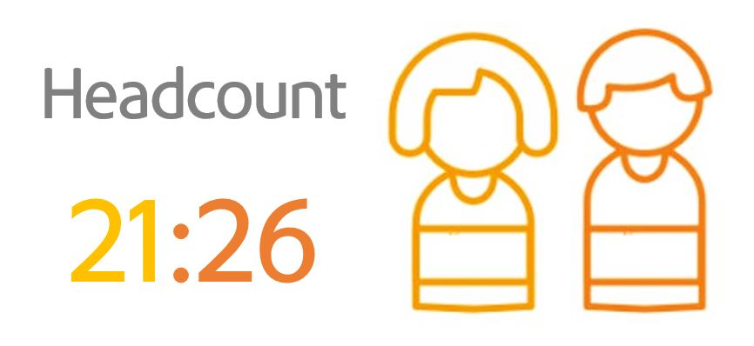
When we signed the charter, NS&I set a target to achieve gender balance in our management and leadership (comprising the Chief Executive, Directors, Assistant Directors and Heads of Teams) within a range of +/- 5 posts. The table below shows our performance as at 31 March 2019 – we currently achieve the target.

In 2018, NS&I set a public diversity index target for the first time:
1) to continue to meet the Women in Finance charter target for gender diversity of our senior managers.
2) to improve the ethnic diversity of all of our managers (meaning ExCo, Assistant Directors, Heads of Department and all line managers) as measured by data collected annually in Q4.
NS&I has met this target by maintaining our women in Finance gender balance and improving our ethnic diversity from 19% to 22%. To build on this, we have set a goal to improve our ethnic diversity further in 2019/20, while maintaining our senior gender balance.
In 2017, the Government introduced legislation requiring organisations with 250 employees or more to publish their gender pay gap. NS&I voluntarily publishes our data, and based on the ‘snapshot’ date of 31 March 2018 NS&I’s gender pay gap data is as follows:

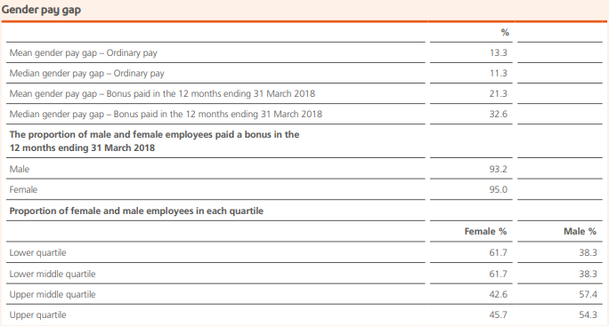

Compared withreporting in the previous year, NS&I’s mean gender pay gap for salaries and for bonus pay has increased by 1.3% and 1.8% respectively. NS&I’s median gender pay gap for salaries and bonus pay has increased by 4.8% and 19.6% respectively.
One of the reasons why NS&I’s gender pay gap has increased between the two years is because, as at end March 2018, we had a male Chief Executive; in March 2017 he had been in post for less than a month and therefore his salary was not included in the pay gap calculation (the official methodology does not include pay for roles which have been filled for only part of the month).
However, this reason does not account for all of the difference. NS&I is committed to fairness and transparency in our pay and it is important for us to understand the reason for this change and to take action to reduce the gap in the future years; therefore we will conduct a deep-dive analysis of the gap in 2019–20.

Recruitment Practice: Encouraging diversity in recruitment and valuing the diversity we have among our own employees is key to our success and effectiveness. We are committed to being a fair and inclusive organisation, respecting what each person brings to our business and recognising the value they add.
No employee or potential employee will therefore receive less favourable treatment due to their race, creed, colour, nationality, ethnic origin, age, language, religion, political or other opinion affiliation, gender, gender reassignment, sexual orientation, marital status, connections with a national minority, national or social origin, property, birth or other status, family connections, working pattern, membership or non-membership of a trade union or, unless justifiable, disability.
At NS&I we are committed to best practice in recruitment and our processes are underpinned by the principle of appointment on merit on the basis of fair and open competition as outlined in Civil Service Recruitment Principles. National Savings and Investments is a two ticks employer and is therefore committed to interviewing all candidates with a disability who meet the minimum criteria for a job vacancy.
The Civil Service Commissioners chair selection panels for all Executive Director level recruitment at NS&I. The Civil Service Commission is committed to the principle of appointment on merit and promotes and supports efforts to get the best candidates drawn from a strong and diverse field.
For other staff recruitment, at the sifting stage, we anonymise applications (removing candidates personal details) and recruiting managers are making decisions based on a candidates experience and nothing else, ensuring that no unconscious bias takes place. Vacancies are advertised in a range of places and we also work with specialist recruitment agencies to attract the most diverse pool of candidates as possible. For example, for senior recruitment we require diverse long lists and short lists. Over the last year, we have recruited one non-executive and three executive directors through fair and open completion, appointing two women and two men. For all roles, over the last year we have increased our direct recruitment via our own website and LinkedIn, and improved the online information available to candidates so that they know more about our approach to diversity and our values. Anecdotal evidence shows this is a key factor for candidates.
A culture of ‘welcoming diversity’: In 2017, NS&I refreshed its organisational values. We have a commitment to being ‘Inspiring, Secure, Straightforward, and Reassuringly Human’ with our colleagues and our customers. We recognise that our efforts to encourage diversity and be more inclusive are critical to living these values. In the same way, diversity helps to drive the way we live our values internally; for example we know that a diverse workforce will inspire ongoing diversity, and that by embracing difference we will be reassuringly human, to our customers, prospective employees and as an employer. In the 2018 Civil Service People Survey, 91% of NS&I employees took part and 83% said they buy into the NS&I values, and only 3% disagreed.
In the last year, we have become a disability confident committed employer and are working towards becoming disability committed. During and after our office refit in 2018, we have made sure that all colleagues requiring a reasonable adjustment in their physical workspace have had their needs met, as a priority. We have also taken action to meet the enhanced standards in the Stephenson Farmer review of Thriving at work, so that we support candidates and colleagues with their mental wellbeing at work, including face-to-face training for all line managers and a cohort of trained mental health first aiders. For the first time, NS&I took part in the MIND Workplace Wellbeing index, which will give us a richer picture of our progress on supporting mental wellbeing and will benchmark NS&I against other organisations. We await the results this Spring.
In the last year, we have also adopted the ‘Happy to talk Flexible Working’ logo promoted by the charity Working Families. Some staff work part time, a majority work have chosen to work compressed hours, through a 9 day fortnight and most work at least one day a week at home.
Our Diversity Allies group of volunteers continues to meet regularly. This group is made up of a cross section of employees from across our business who have helped to create, communicate and lead the ‘Welcoming Diversity Plan’. This is sponsored and led by our Director of People and Strategy sets out the ways that NS&I will empower, invest and inspire diversity in our workforce. As well as all the actions already described in this statement, over the last year members of the group have undertaken specialist equality and diversity training; and made links with other networks in partner organisations, for example the HM Treasury LGBTQ network, and Atos Pride. Actions are championed by members of the group and by leaders within NS&I, progress is evaluated and the plan is also designed to incorporate regular feedback from employees, partners and colleagues. This approach highlights that NS&I is committed to fulfilling our duties to our colleagues but that we will challenge ourselves to reflect and improve and to set goals that encompass wider strategies for an inclusive culture as well as improvement in the diversity of our workforce.
Putting equality and diversity at the heart of our customer operations:
NS&I is committed to treating our customers fairly and with the dignity and respect to which they are entitled. To ensure we do this we have invested in both leadership and insight and we have identified a ‘Member Champion’, the Director of Retail, to provide leadership on this issue from a customer perspective as well as undertaking customer surveys across a broad spectrum of customer types including a range of socio-economic and age groups.
This commitment is reflected in our ‘Vulnerable Customers Policy’ and our Customer Experience Principles and Standards. These guide the business to ensure we duly consider fair customer treatment and customer vulnerability when we define and deliver our products and services and in all aspects of our work.
NS&I aims to deliver a balanced portfolio of products that are accessible across a range of channels to suit varied customer preferences. As part of a program to increase channel accessibility and broaden our range of contact options in 2018/19, we delivered two new customer interaction channels; webchat and Alexa prize checking. Webchat, provides real time information through a live text based service accessed at nsandi.com. This form of contact is especially well suited to vulnerable customers with issues interacting on traditional phone or paper channels. The Alexa Premium Bond skill allows customers with the device to check their Premium Bond prize winnings through a voice request.
During the past year, we have reviewed our products and marketing including external research and customer feedback, to ensure that products and associated services continue to meet all customer needs. As part of this review, we identified that younger people were under-represented in our savings book and risk being isolated from the benefits a strong saving base can provide through life. As a result, we have taken positive action for younger savers, by for example, lowering investment limits to make our products more inclusive and encourage a regular savings culture. This is not exclusive and has been made available to all customers regardless of age who wish to take up the offer. In addition, we improved access to Premium Bonds to allow grandparents to purchase for children to further encourage the savings habit. To raise awareness of the changes our website was updated and a marketing campaign was launched targeted at younger people, their parents and grandparents providing savings information.
On 1 February, NS&I reduced the minimum initial investment for Premium Bonds from £100 to £25. Already this change is having an encouraging result for some more vulnerable groups, shown below, where significantly more people are saving. We will continue to engage with these customers to see how we might continue to meet their needs:
- “Single customers & couples getting by” and uplift of those saving from 2% to 7%;
- “Families getting by” an uplift from 1% to 10%; and
- “Customers starting out” an uplift from 1% to 6%.
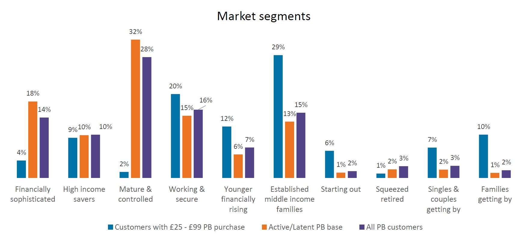
Where vulnerable customers may be excluded from access to certain products as a result of their vulnerability NS&I endeavours to ensure suitable exception processes are in place, for example with the launch of Investment Guaranteed Growth Bonds (on behalf on HM Treasury) in April 2017 and NS&I’s Junior ISA in August of 2017.
Our public access arrangements: We recognise that some groups will not have the same level of access to information as others. For example e.g. people with sensory, learning, communication and mobility disabilities may require printed information in other formats. We will provide different ways for our customers to access our information services and suitable alternative formats. NS&I is committed to ensuring that information and services are fully accessible to all parts of the community. We keep our arrangements under review to ensure that this remains the case. We’re committed to making sure our website is accessible to as many of our customers as possible. We aim to conform to the ‘Double A’ level of the World Wide Web Consortium (W3C) Web Content Accessibility Guidelines 2.0 and we develop and test accordingly.
Partnership working: NS&I meets the Public Sector Equality Duty (PSED) primarily through setting policies and standards for its service delivery partners and ensuring that the impact of policy and service delivery avoids discrimination, promotes equality and best practice.
NS&I will work with its partners to promote equality by:
- sharing existing information and good practice
- gathering new information
- developing joint consultation and involvement methods and structures where appropriate
- developing joint working and co-delivery of services where practicable
- pooling budgets and resources where practicable
- promoting the living wage to our suppliers, and seeking a living wage commitment when major contracts are procured.
In March 2019, NS&I became an accredited living wage employer, having received formal accreditation from the Living Wage Foundation. This commits to ensure all staff are paid at or above the Foundation’s living wage rates.
Conclusion: We hope the steps we are taking within NS&I, demonstrated within this statement, show how committed we are to improving Equality and Diversity within our organisation. We also hope it demonstrates how we:
- comply with the Equality Act and the PSED across our functions
- ensure that our policies and practices further the aims of the PSED
- ensure that equality implications are fully considered when making decisions and formulating policies and practices
We will track progress in a number of ways:
- Customer Satisfaction Rates
- Customer Effort Scores
- Annual Employee Surveys
- Employee and Customer Diversity Statistics
- Recruitment Audit Results
- Partnership Surveys
- People Survey
- Service Delivery Measures
- Women in Finance Charter Target
- Executive Committee Minutes
- Retail Experience Sub-committee Actions
- Conduct Committee minutes
- Complaint Tracking
NS&I welcomes your comments or suggestions on how we might improve the Statement. Please contact us at customerservices@nsandi.com.

